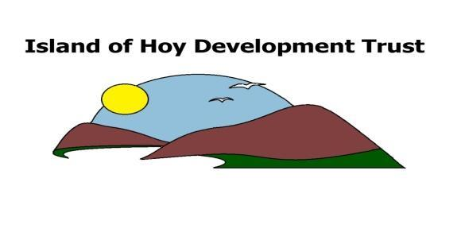
HOY AND WALLS
COMMUNITY LARDER
In response to the 2020 Covid-19 pandemic, the Island of Hoy Development Trust has acquired funding from the Supporting Communities Fund to establish the Community Larder. This facility is being set up to help Hoy and Walls residents who are in need as a result of the coronavirus crisis. The Trust will use the funds to purchase basic household larder supplies which will be delivered to households. All applications for assistance will be treated in the strictest confidence.
About you (main applicant)
Name
Address
Email
Phone
More about you | Please tick which applies to you:
Single Adult
Couple
Single parent | If so, how many children
Family | If so, how many children

Please check the following terms and conditions and sign below to acknowledge that you have read and agree with the following. Tick the box/boxes that apply to you.
- I/we am/are experiencing genuine current hardship ꙱
- I have lost my job/business/primary income as a result of the pandemic ꙱
- I/we do not have any savings to fall back on ꙱
- I/we are unable to meet basic household costs this month food/rent/fuel ꙱
- Individuals/families in receipt of benefits/Working Tax Credits/Child Tax Credits/Pension Credits ꙱
- Individuals who have applied for universal credits and are awaiting their first payment ꙱
- Individuals who have had to stop working to provide childcare because of the restrictions ꙱
- Individuals who have lost their only source of income e.g. Zero hours contract or Self-employed ꙱
Terms & Conditions: I am applying to the Community Larder for the reasons I have given above. I understand should my circumstances change, I will inform the Development Trust.

Signed: Date:
Please email the form to: denize.lace.iohdt@gmail.com if you are unable to do that, or wish to discuss it please contact Denize on 701356.

In order for us to manage the overall scheme we can assure you that your details will be handled in the strictest of confidence and in compliance with general data protection regulations (GDPR)

