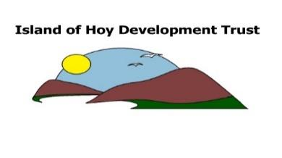
IMPORTANT ANNOUNCEMENT
COMMUNITY SUPPORT FUND

The Island of Hoy Development Trust, like other trusts around the country, has been working on a community coronavirus support plan. This is to ensure that people on the island who are affected by the coronavirus crisis through losing their job or experiencing a reduction in income, and need help with household expenditure (general provisions, energy bills) in the weeks and months ahead, are offered some assistance.

The Trust is making funds available immediately and we are working hard to secure additional support. This scheme will be reviewed on an ongoing basis.
The fund is open only to Permanent Hoy and Walls residents in need of immediate support: This will commence on Tuesday 14th April 2020
- Individuals/families in receipt of benefits/Working Tax Credits/Child Tax Credits
- Individuals who have applied for Universal Credits and are awaiting their first payment.
- Individuals who have lost their only source of income e.g. zero hours contract or self-employed.
- Individuals who have had to stop working to provide childcare because of the current restrictions.
HOW IT WORKS:
- Each Household is entitled to receive £10 per person, per week up to a maximum of £50 for a family with children under the age of sixteen.
- All you need to do is contact the Wellbeing Coordinator through the Information and Support Hub.
- The Information and Support Hub can also offer guidance on any socio-economic issues that could be causing anyone anxiety in regards to Debt, Social Care, Benefits, Advocacy, Fuel Bills, Housing, isolation etc.
In order for us to manage the overall scheme we can assure you that your details will be handled in the strictest of confidence and in compliance with general data protection regulations (GDPR)
Please understand this is currently for those who need immediate support and is not intended as an addition to existing benefits or source of income.

For further information or to see if you are eligible please contact Denize on 701356 or email denize.lace.iohdt@gmail.com

