NOTICE OF ANNUAL GENERAL MEETING
12th May 2021 at 7.30pm to be held as a virtual AGM using Zoom

NOTICE IS HEREBY GIVEN that the ANNUAL GENERAL MEETING of the MEMBERS of the above company will be held on the 12th day of May 2021 at 7.30pm. The meeting will be a virtual AGM using “Zoom” as the platform.

If you wish to join the virtual meeting, please contact Deanna Johnston, either by email dea.johnston.iohdt@gmail.com or phone on 01856 701356 (Monday to Wednesday 10.30 – 15.00). A Zoom meeting link will then be sent out to anyone who has requested to join.

Any member entitled to attend and vote at the above meeting is entitled to appoint a proxy to attend and vote instead of him. A proxy need not be a member of the Company. If anyone wishes to stand as a Director, proposal forms are also available. Please contact either dea.johnston.iohdt@gmail.com or liz.davidson.iohdt@gmail.com if you require either form. Forms must be returned by 17.00 on Monday 10th May 2021, either to the above emails or to the office.

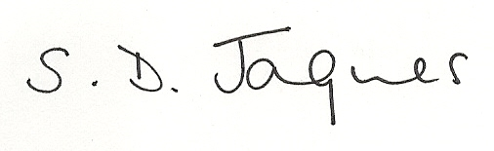
Deborah Jaques
Director

